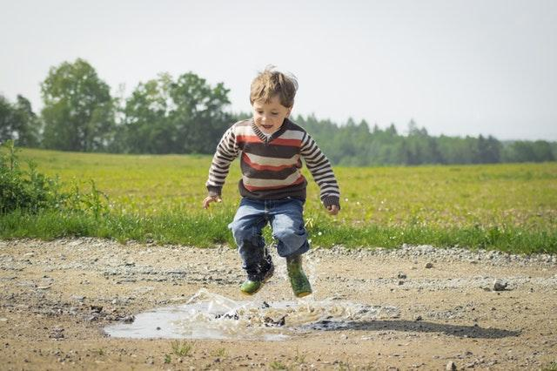

6 Things to Know About Autism and Backyard Sensory Integration

Autism Spectrum Disorder isn’t something that defines a child. It’s just a part of who they are. However, there are a few things that are almost universally true about ASD kiddos. These tips from A Spark of Inspiration can help you understand the needs and emotions of your kiddo to improve both their mood and your relationship.

1. Autism is a Spectrum Disorder

Autism spectrum disorder is a developmental disability that affects one in every 54 children in the United States. As a spectrum disorder, there are various symptoms ranging in severity and complexity. Generally, autism affects a child’s social skills, communication abilities and behaviors in a way that poses challenges for normal societal function. With early treatment and management, children with autism can adapt to their communities and become fully functional members of society.

2. There are Numerous Specific Conditions

The autism spectrum can be broken down into more specific conditions including Asperger’s Syndrome, Childhood Disintegrative Disorder and Pervasive Developmental Disorder - Not Otherwise Specified (also known as atypical autism). All of these have their own unique symptoms and circumstances. While atypical autism is no longer an official diagnosis, the child may struggle with many of the same challenges as others with autism. However, they are symptom-free in other areas and therefore less severely affected.

3. The Symptoms of Autism Vary Wildly

One common symptom of autism is echolalia, where the child repeats noises and phrases that they hear. Echolalia is common in toddlers, but children who continue this behavior later into childhood could suffer delayed speech and communication development. Other issues with communication might include an inability to follow directions, trouble grasping reasons, avoiding eye contact and an inability to express needs.

4. Sensory Processing Issues are Common

Sensory processing is a problem for many children with autism. Children with sensory processing issues are either over-sensitive or under-sensitive to their surroundings. Some kids with sensory processing issues have a lot of problems with play, particularly outside.

5. Backyard Sensory Integration Can Help a Child Overcome Some Issues

Sensory integration therapy helps to regulate a child’s responses to new smells, sights, sounds, tastes and experiences of touch. In a controlled environment with their guardian, they can learn to respond appropriately to sensory input and eventually their brain normalizes new experiences. Over time, the child grows more in control of their behavior and reactions to new sensations so they can adapt outside of the home as well.

Gravitational insecurity overwhelms children when they are out of control of their movements. Children with gravitational insecurity may get nervous and uncomfortable when on machinery like elevators and escalators. Parents can help their kids adjust to gravitational insecurity by participating in activities that stimulate the vestibular system in the inner ear. A backyard swing set can provide several activities that accomplish this. Beyond your basic swing, you can look for features such as slides, trapeze bars, seesaws, spring riders and monkey bars.

Backyard gardening is a great way to use aspects of horticulture therapy for your child’s benefit. It is also wonderful for helping children fine-tune their motor skills. It encourages focus and teaches kids about finesse as they handle flowers, herbs, fruits and vegetables. Every action from pulling on a pair of gardening gloves, to digging holes to harvesting berries, helps them grow accustomed to new sensory experiences.

6. Kids on the Spectrum Are Prone to Wandering

It’s crucial that you keep track of your autistic child. A home security system camera could help you monitor your child’s whereabouts, and there are also smart home devices that can help. For example, you could add a door sensor in case they leave unsupervised or a flood sensor if you child uses too much water.

****

There are many ways you can create a therapeutic experience in the backyard for your child. My Autism states that activities as simple as outdoor water play and dance or movement exercises can be therapeutic -- it all depends on your child’s needs. If you still have questions, consult a physical therapist that specializes in sensory integration therapy.

We hope you’ve found this information helpful as you learn to navigate your career and your family. As always, Army of Mums strives to arm our readers with the tools they need to succeed.

Image via Pexels

